# 1. INTRODUCTION

## 1.1. Overview

Malaria is a deadly, infectious mosquito-borne disease caused by Plasmodium parasites. These parasites are transmitted by the bites of infected female Anopheles mosquitoes.

Typically the first symptoms of malaria are similar to the flu or a virus wh you usually start feeling sick within a few days or weeks after the mosquit bite. However these deadly parasites can live in your body for over a year without any problems! Thus, a delay in the right treatment can lead to complications and even death.

Hence early and effective testing and detection of malaria can save lives.

It is pretty clear that malaria is prevalent across the globe especially in tropical regions. The motivation for this project is however based on the nature and fatality of this disease. Initially if an infected mosquito bites yo parasites carried by the mosquito will get in your blood and start destroy oxygen-carrying RBCs (red blood cells).

## 1.2. Purpose

Nearly half the world’s population is at risk from malaria and there are over 2 million malaria cases and approximately 400,000 deaths due to malaria every year.

This gives us all the more motivation to make malaria detection and diagnosis fast, easy and effective.

1. With regular manual diagnosis of blood smears, it is an intensive manual process requiring proper expertise in classifying and counting the parasitized and uninfected cells. Typically this may not scale well and mig cause problems if we do not have the right expertise in specific regions around the world.

1. Deep Learning models, or to be more specific, Convolutional Neural Networks (CNNs) have proven to be really effective in a wide variety of computer vision tasks.
2. Automated malaria detection using deep learning models like CNNs could be very effective, cheap and scalable especially with the advent of transfe learning and pre-trained models which work quite well even with constraints like less data.

# 2.LITERATURE SURVEY

## 2.1. Exis ng problem

At present, the recognition of Malaria parasite in single cell slide is totally manual. This procedure could be rearranged by capturing an image of the blood smear and afterwards utilizing the proposed model to arrange whether the cells are contaminated or not. The proposed model uses the utilization of image processing systems to improve existing techniques and abbreviate the time taken for recognition of malaria parasite in blood tests. The dataset is manually collected from the CDC’s Division of parasitic infection and Malaria.

The Malaria Detection from thin film blood smear images demands segmentation of single blood cells from the microscopic blood slide images which can be taken from a pathologist and the dataset would contain cell images that are not segmented. Hence, segmentation in the proposed method is done using a variety of image processing techniques.

Edge detection techniques and segmentation techniques used in this system overcomes the issue of overlapping of cells by eliminating the noise and finding the discontinuities of the cells. It differentiates each cell and detects the infection in the cell using morphological segmentation. Also, all the images are raw and have different intensities, and since there is no uniformity in all the images, detection of cells and infection is very difficult.

## 2.2.Proposed Solu on

We propose an image processing model for detection of malaria infected cells. We use image processing techniques to detect parasite-infected red blood cells in thin smears on standard microscope slides. The most widely used presentday method is analyzing thin blood smears under a microscope, and visually searching for contaminated cells. A clinician manually counts the number of parasitic red blood cells - sometimes up to 5,000 cells (according to WHO protocol) .Malaria could be forestalled, controlled, and relieved all the more adequately if an increasingly precise and effective symptomatic techniques were accessible. We have utilized image processing procedures to identify the nearness of malaria contaminated cells. And to classify the stage of malaria whether it is falciparum which is the most deadliest stage in malaria or non-falciparum, for this we use machine learning technologies.

We work on a a parasite detection technique which is based on digital image processing. Images of thin blood smear are used and with the help of image processing approach the parasite in the cells are identified , i.e Detection of malaria parasites using digital image processing.

In this project, we will be building a deep learning model that can detect and classify malaria disease. A web application is integrated into the model, from where user can upload an x-ray image and see the analyzed results on UserInterface.

## 3. THEORETICAL ANALYSIS

### 3.1. Block diagram

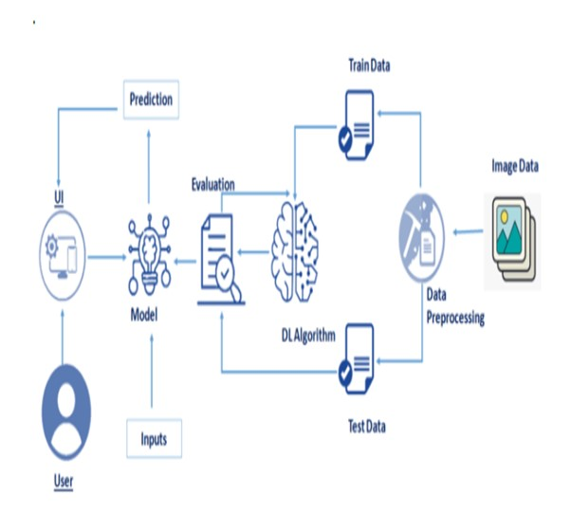

### 3.2. Hardware/So ware Designing

To complete this project we have used the following software and packages -

Anaconda Navigator –

Anaconda Navigator is a free and open-source distribution of the Python and programming languages for data science and machine learning related applications. MacOS.Conda , cross-platform, package management system.

Anaconda comes with so very nice tools like JupyterLab, Jupyter Notebo QtConsole, Spyder, Glueviz, Orange, Rstudio, Visual Studio Code. For this proje we will be using Jupiter notebook and spyder.

To build Deep learning models we have used the following packages – Tensor flow- To build and deploy ML applications.

Keras- To make high level neural network API easier and more performant. To models using image data augmentation

Flask - used for building Web applications.

# 4.EXPERIMENTAL INVESTIGATIONS

To develop an efficient and highly accurate model for the detection of the malaria parasite from segmented cell images, a series of experiments involvin both machine learning and deep learning techniques were performed.

It is important to note that the size of the model was also considered as an important factor along with performance to ensure the viability of the models lower-cost smartphones.

Comparable performance was achieved to confirm that the proposed model is not localized or biased to the dataset on which it was trained.

By the end of this project we :

* know fundamental concepts and techniques of the Artificial Neural Netwo and Convolution Neural Networks
* Gained a broad understanding of image data.
* Worked with Sequential type of modeling
* Worked with Keras capabilities
* Worked with image processing techniques
* know how to build a web application using the Flask framework.

## 5. FLOWCHART

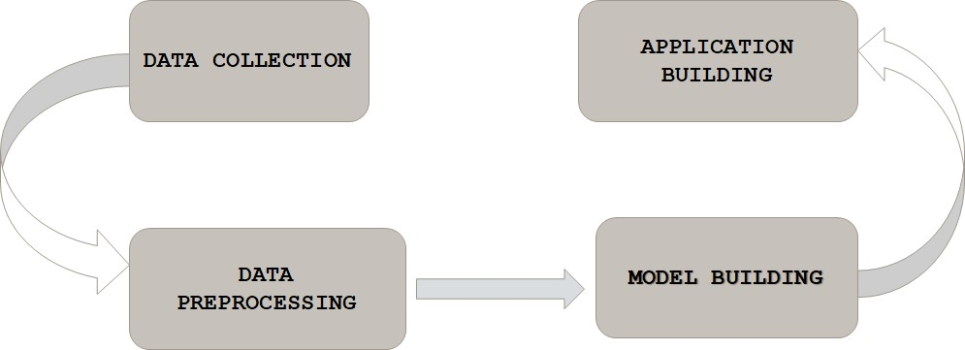

**6.RESULT**

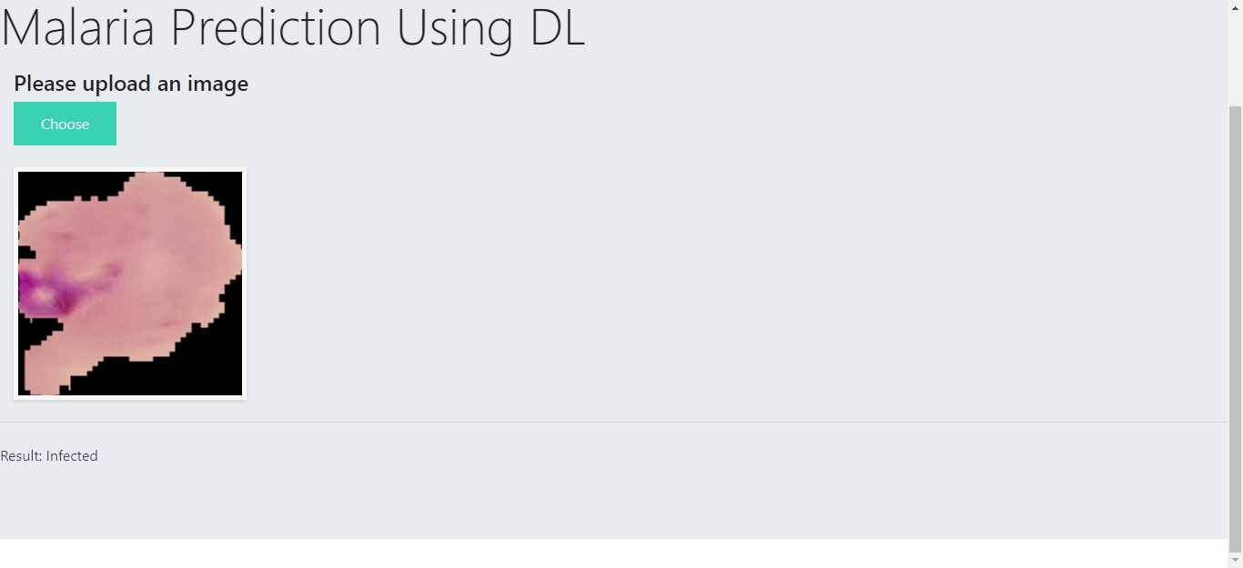

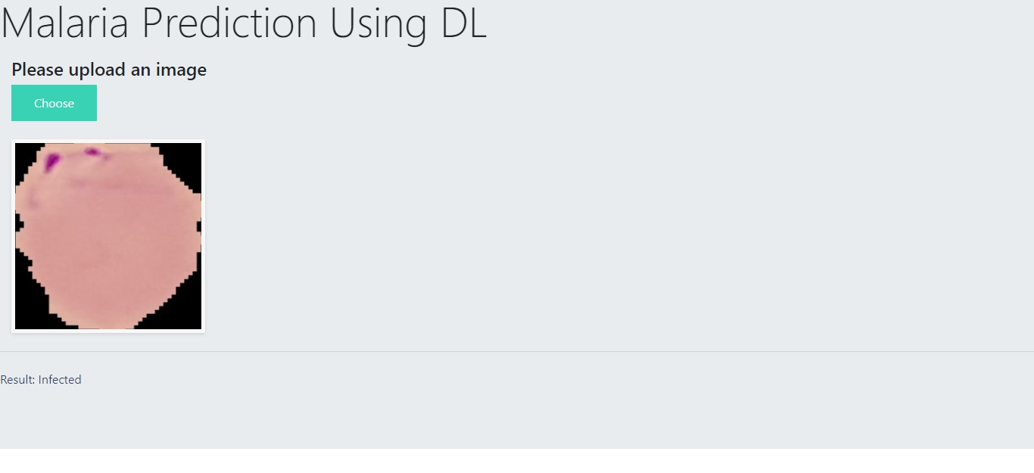

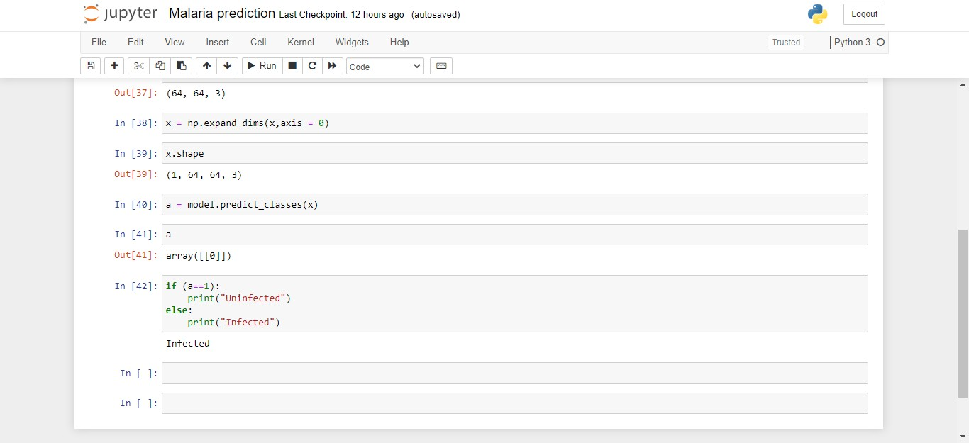

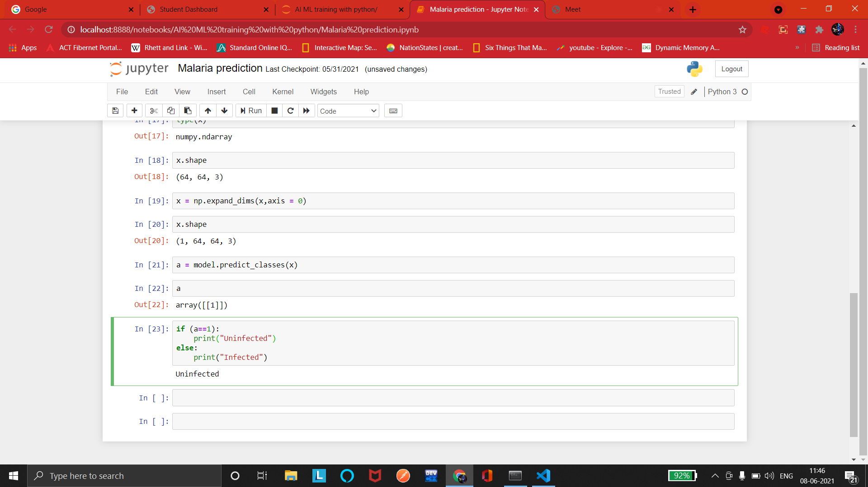

# 7.ADVANTAGES & ADISADVANTAGES

ADVANTAGES-

Automated malaria detection using deep learning models like CNNs could be very effective, cheap and scalable especially with the advent of transfer learnin and pre-trained models which work quite well even with constraints like less data.

It reduces images to a form which is easier to process without losing features which are critical.Image pre-processing required is much less compared to oth algorithms.

Deep learning does not require the design of handcrafted features, which is o of its biggest advantages.

DISADVANTAGES~~-~~

There has been a lot of fine-tuning of these methods to make them perform better for blood smear images, and more so for the image analysis methods than for machine learning.

Despite the large number of publications, the performance numbers that have been published are very unsatisfying from a clinician’s point of view.

It requires a large training data.

It requires appropriate model.

# 8.APPLICATIONS

There has been a lot of fine-tuning of these methods to make them perform better for blood smear images, and more so for the image analysis methods than for machine learning.

There is certainly the potential that some of these methods gain importance outside malaria diagnosis, in particular for preprocessing and for detecting an segmenting red blood cells in other applications.

Working on this project lead us to believe that this work can play a part toward building a fully automated system for malaria parasite detection which may be useful in resource-constrained areas in the foreseeable future.

The same methods used in this project , can help In medical science, by makin more models to work for many other diseases diagnoses. With this, medical technology can grow faster and be able to build 3D models that can predict accurately.

The increasingly growing number of applications of machine learning in healthcare allows us to glimpse at a future where data, analysis, and innovation work hand-in-hand to help countless patients without them eve realizing it. Soon, it will be quite common to find ML-based applications embedded with real-time patient data available from different healthcare systems in multiple countries, thereby increasing the efficacy of new treatment options which were unavailable before.

# 9.CONCLUSION

In this project, we built a deep learning model that can detect and class malaria disease. A web application is integrated into the model, from where u can upload an x-ray image and see the analyzed results on UserInterface. A GUI based application which uses a custom CNN model to predict if uploaded cell image is parasitized or uninfected. System will read the ima uploaded by the user, augment it and will use the saved custom model to det whether the disease is present or not in the patient and thus display the res in a user-friendly language.

Malaria is a curable disease, with drugs available for treatment, including drug that can help prevent malaria infections in travelers to malaria-prone regions. However, there exists no effective vaccine against malaria yet, although this is area of active research and field studies. Once infected, malaria is a rapidly progressing disease, with a serious risk of developing into severe and cerebral malaria with neurologic symptoms for P. falciparum infections. Therefore, a timely diagnosis of malaria is very important. Although malaria can be diagnos in many different ways, there is room for improvement for current malaria diagnostic tests including reducing cost, increasing specificity, and improving ease of use. Through this , we can make the diagnosis of malaria very fast and convenient.

So, more automations must be brought in this field , and make the detection o diseases more effective and accurate.

# 10.FUTURE SCOPE

Classical approaches to feature computation and selection run the serious danger of being superseded soon by techniques not relying on handcrafted features, such as deep learning in particular.

In this project, we have designed & developed a deep learning model based on a convolutional neural network (CNN) which automatically classifies and predi infected cells in thin blood smears on standard microscope slides.

Deep learning is the latest trend in machine learning, which has already boost the performance in many nonmedical areas. Deep learning typically requires large training sets. This is the reason why medical applications have been amo the last applications to adopt deep learning, as annotated training images are significantly harder to obtain because of expert knowledge requirements and privacy concerns. But through machine learning , there can be a drastic improvement in the Medical field , which will inturn help the world grow . In many cases, it will also enable early discovery and treatment accessibility in remote or developing places, as ML can significantly reduce costs and necessit for doctor appointments.

Overall, ML in healthcare is an incredible development that will increase efficiency and accuracy in disease detection.

# 11.BIBILOGRAPHY

1.

https://www.ncbi.nlm.nih.gov/pmc/articles/PMC7277980/#app2-diagnostics-1 00329

1. https://www.kaggle.com/iarunava/cell-images-for-detecting-malaria
2. https://keras.io/api/preprocessing/image/
3. https://victorzhou.com/blog/intro-to-cnns-part-1/

5.

file:///C:/Users/godam/Downloads/ImageAnalysisandMachineLearningforDete ngMalaria.pdf

## Detect Malaria Using IBM Cloud

6.

https://towardsdatascience.com/detecting-malaria-with-deep-learning-9e45c1 4b60

7. https://www.hindawi.com/journals/wcmc/2020/8895429/